User Guide

WebbiSkools Quiz Manager

Aimee Craig

2019

Contents

Overview 2

Prerequisites 2

Running the Application 2

Running the Test Suite 5

Using the Application 6

Login 6

Logout 7

Viewing a Quiz 7

Creating a Quiz 7

Editing a Quiz 8

Deleting a Quiz 8

# Overview

This web application has been designed to allow users to create, read, update, and delete quizzes and their containing questions and answers. You must have a pre-existing account to login and use the web application. If you do not have an account then refer to the “Adding User Accounts” section of this document to create one.

# Prerequisites

In order to run the web application, you will need the following:

* [.NET Core 3.0 SDK](https://dotnet.microsoft.com/download/thank-you/dotnet-sdk-3.0.100-windows-x64-installer)
* [Google Chrome](https://www.google.com/chrome/)
* Windows operating system

# Running the Application

1. Open the project folder and double-click on **RunApplication.bat** to start the web application.

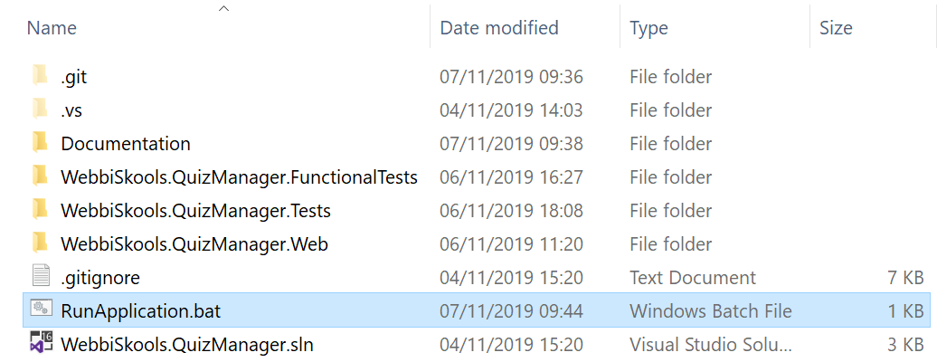

Figure : RunApplication.bat file location

1. Access the web application by opening a browser and navigating to <https://localhost:5001>.

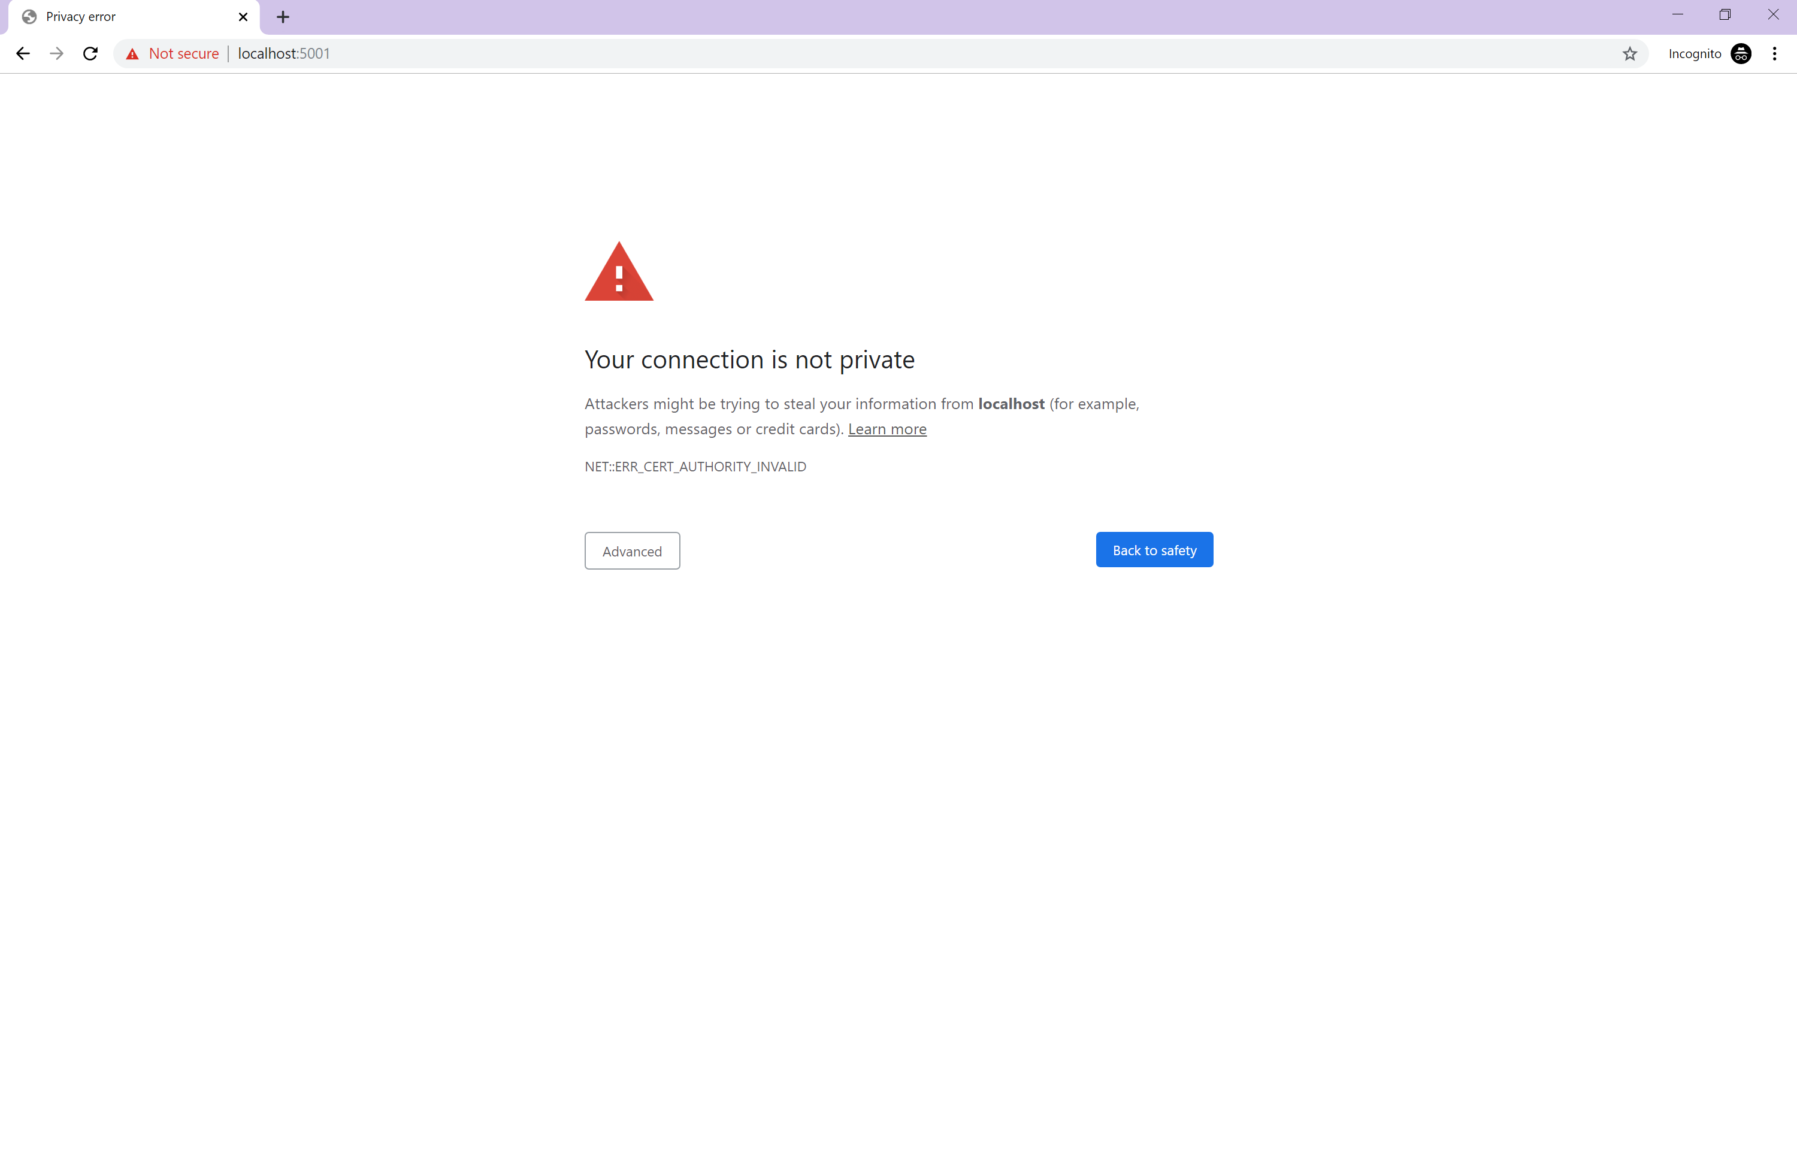

Figure : Navigating to <https://localhost:5001>

1. Click the advanced button and then click the “Proceed to localhost (unsafe)” link.

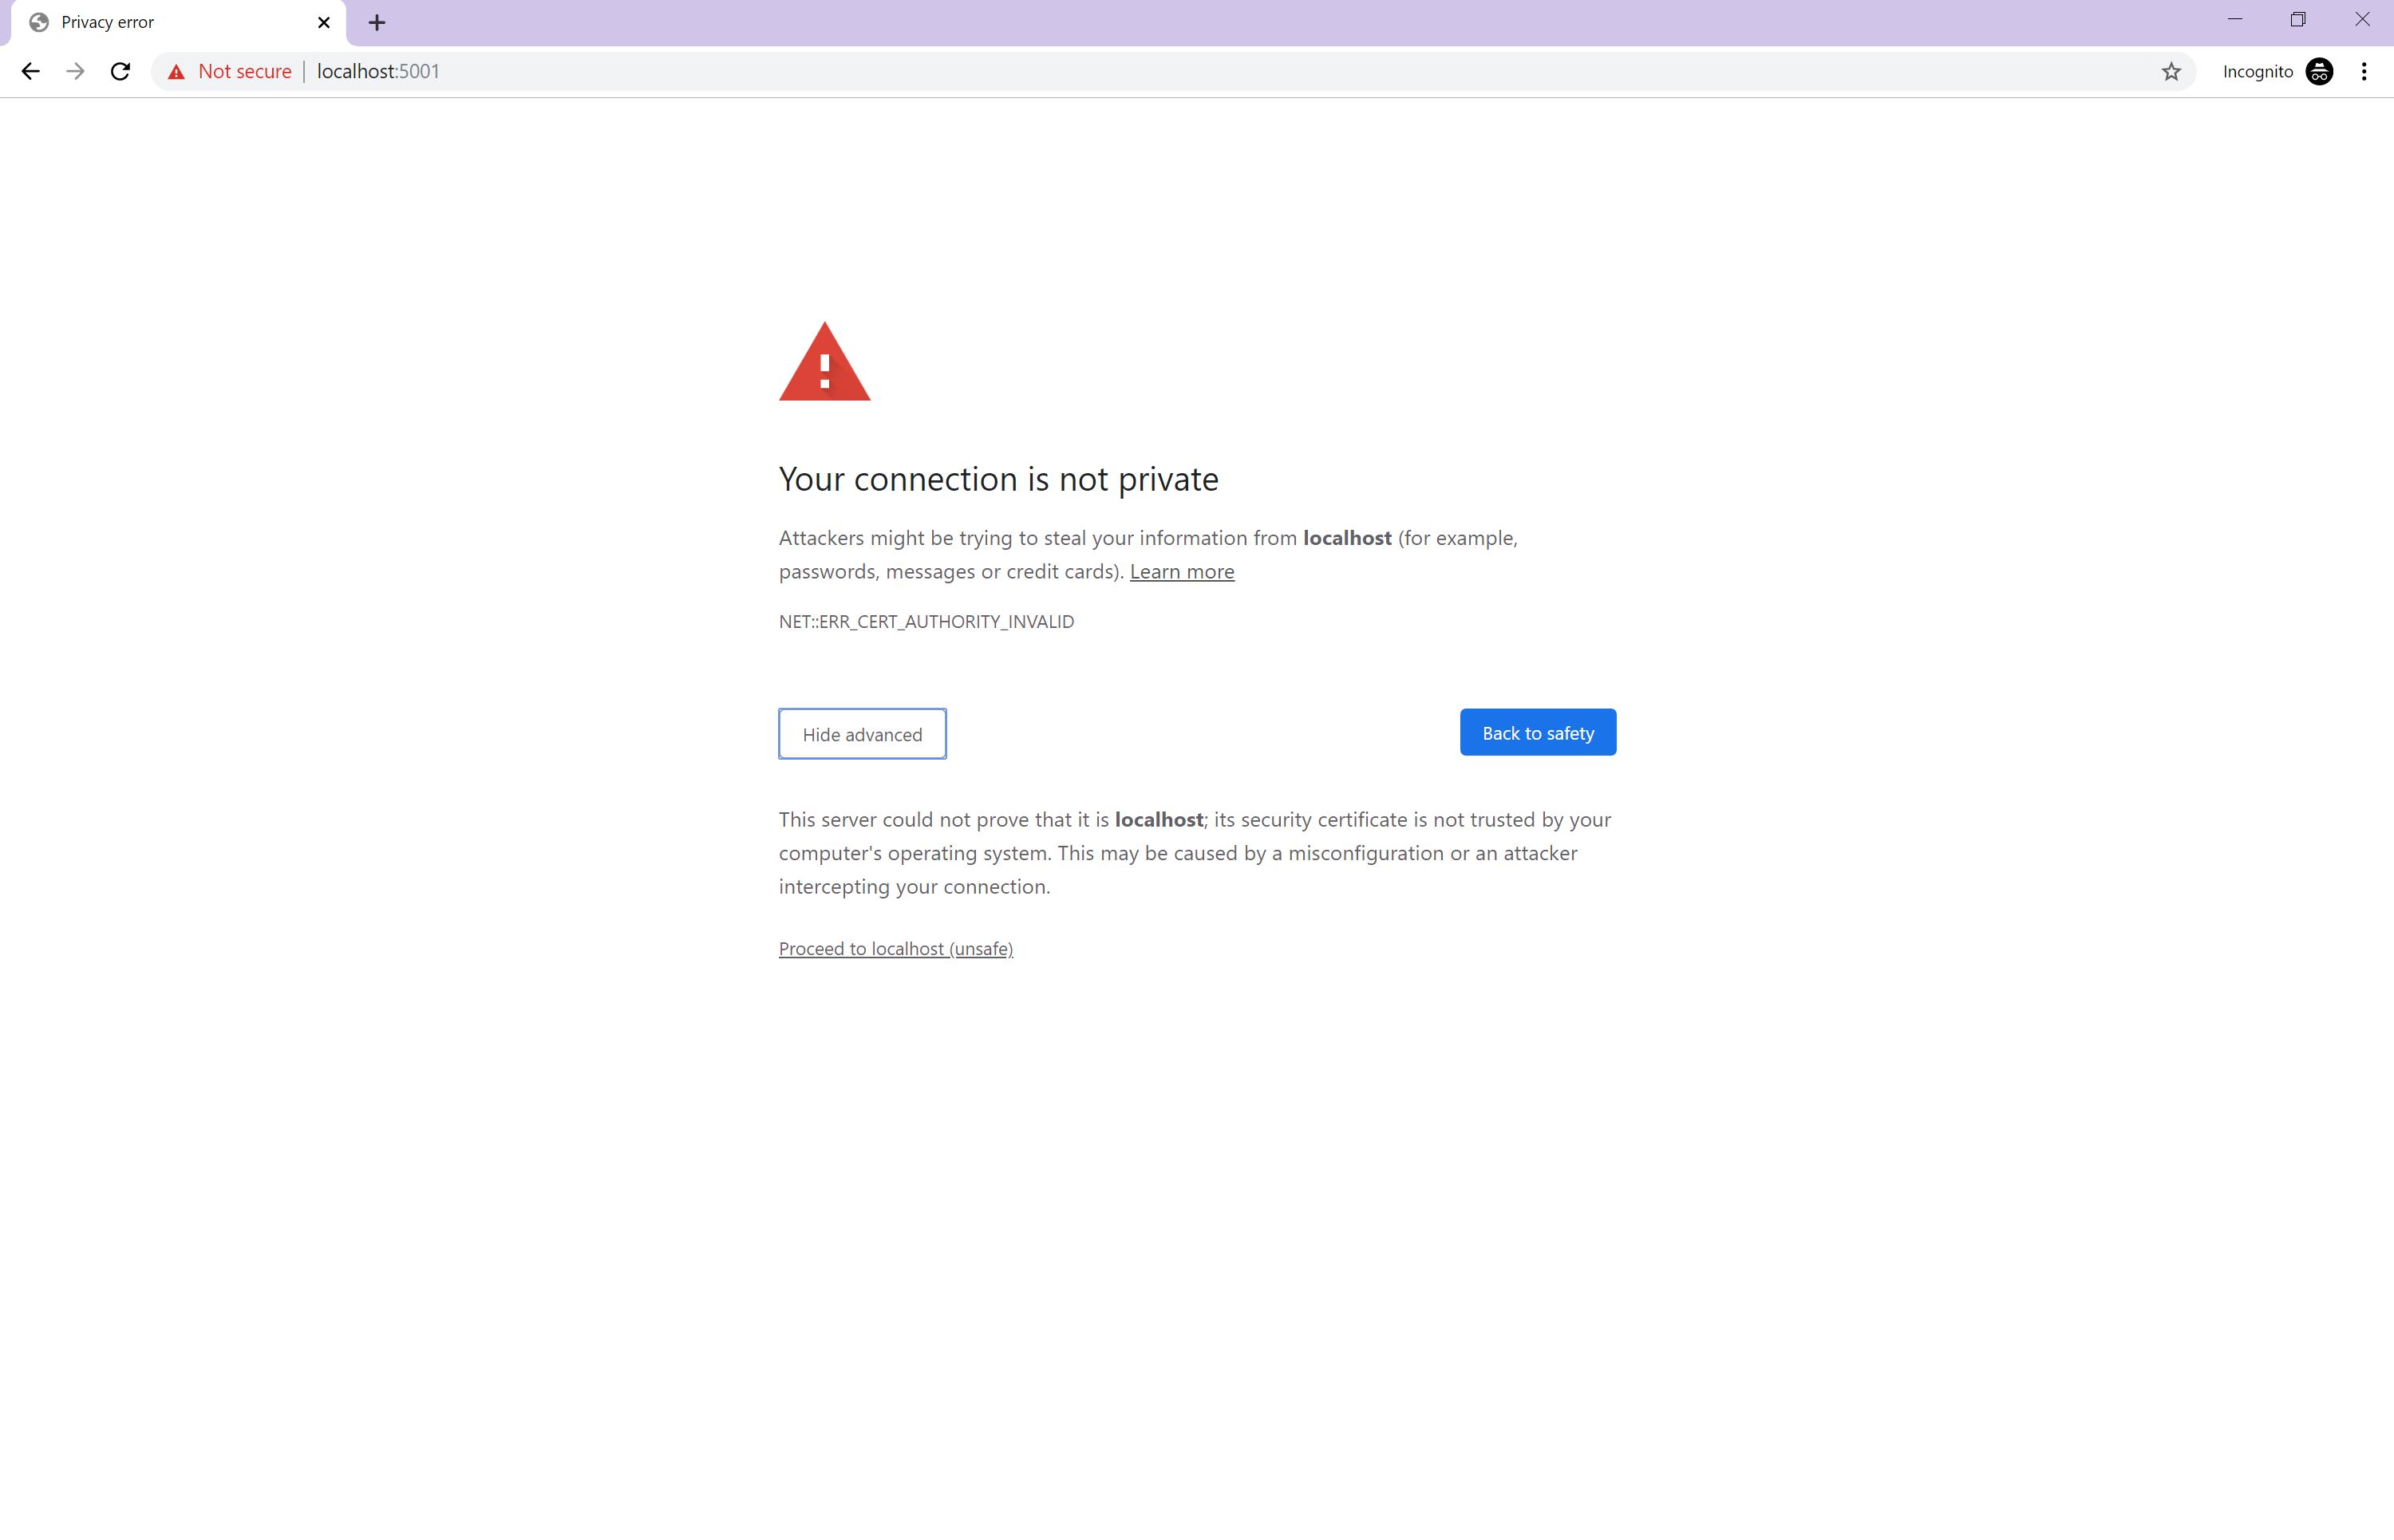

Figure : Navigating past “connection is not private” warning

1. You should now see the first page of the web application.

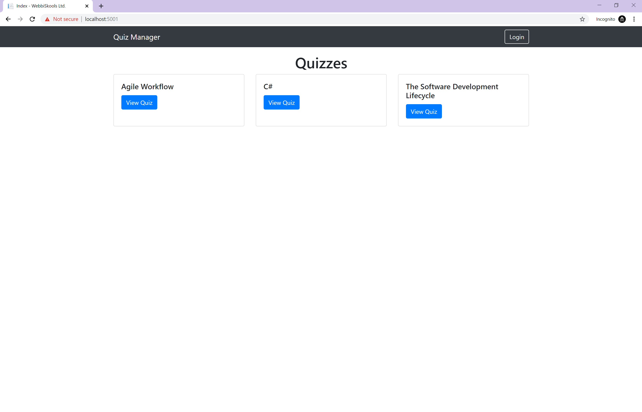

Figure : Quiz Manager homepage

# Running the Test Suite

**IMPORTANT: Ensure that you are running the application before running these tests. You can do this by following the steps in the “Running the Application” section.**

1. Open the project folder and double-click on RunTests.bat to run the test suite.

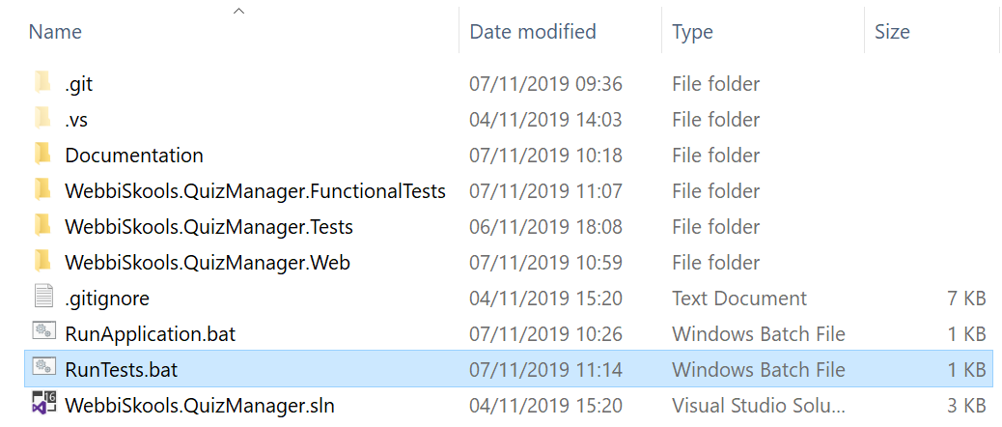

Figure : RunTests.bat file location

The script first runs all the unit tests and the result can then be seen in the command line window.

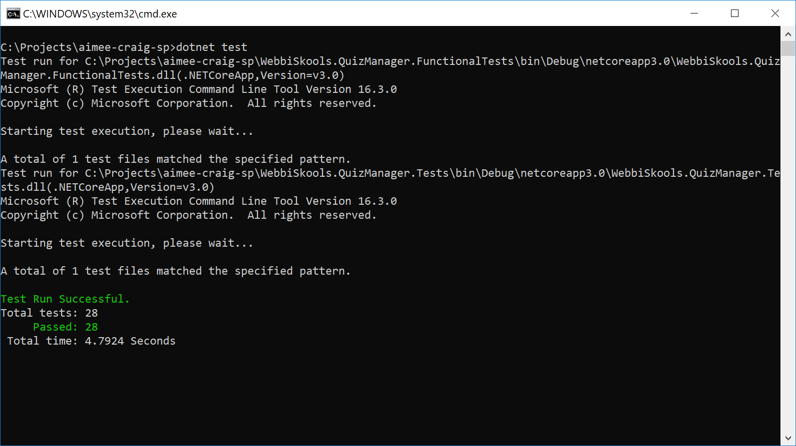

Figure : Unit tests output

The script will then begin opening multiple instances of the Google Chrome browser as it runs each functional test. Once all functional tests have finished running, the result can then be seen in the command line window.

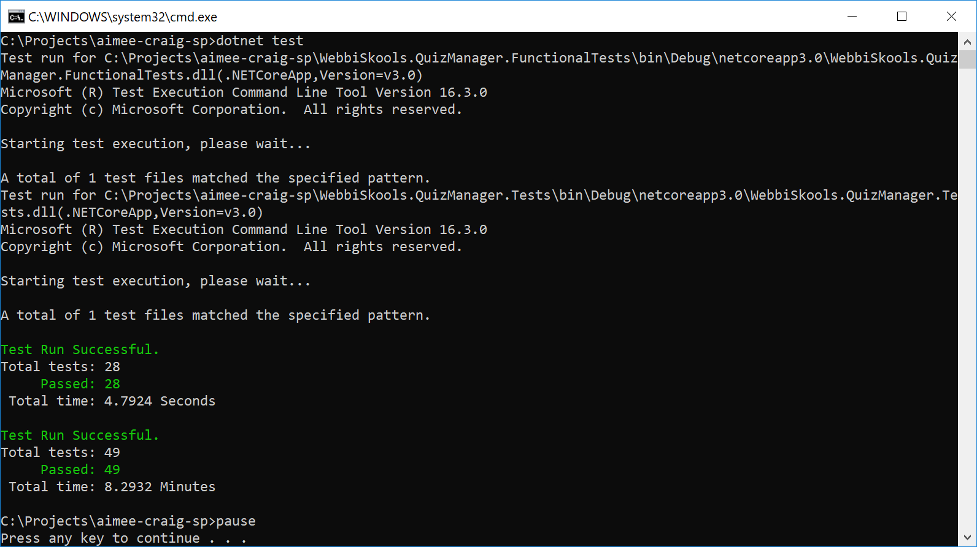

Figure : Functional tests output

Once you have read the results of the unit and functional tests, you can close the command line window by pressing any key.

# Using the Application

## Login

Users are given one of three permission levels, restricted, view or edit. There are test accounts for each of these permission levels already added into the database for you to use. The details for each of these are below.

|  |  |  |
| --- | --- | --- |
| Permission Level | Username | Password |
| Restricted | RestrictedPermissionsUser | password |
| View | ViewPermissionsUser | password |
| Edit | EditPermissionsUser | password |

To log in to one of these accounts, navigate to <https://localhost:5001> and click the Login button in the top right hand corner of the page. If you are unable to see this button it is likely the screen size of the device you are browsing on is too small. In this case, click on the button with three horizontal lines in the top right hand corner to show the Login button.

This will take you to the login page where you can fill in your username and password. Note that the username is not case sensitive. Upon successful login, you will be redirected to the list of all available quizzes.

## Logout

Providing you are logged in to an account, the Login button will be replaced with a Logout button. Clicking this button will sign you out of that user account and redirect you back to the Login page.

## Viewing a Quiz

To view a quiz, click on the View Quiz button of the particular quiz you’d like to view. You will be redirected to a page that displays all questions within that quiz. If you are logged in as a user that has the View or Edit permission level then you will also see a button underneath each question labelled “Show Answers”. Click the “Show Answers” button to reveal the possible answers to each quiz. Users with the Restricted permission level will not see this button and will not be able to view the possible answers for each question.

## Creating a Quiz

To create a quiz, you must be logged in as a user with the Edit permission level. Once you are logged in as a user with the Edit permission level you will see a new button in the top right hand corner of the page labelled Create. If you are unable to see this button it is likely the screen size of the device you are browsing on is too small. In this case, click on the button with three horizontal lines in the top right hand corner to show the Create button.

You will be presented with a form asking for the quiz’s title, a question and at least three answers. You can add a question by clicking on the Add Question button. This will add another question box and three answer boxes. This button can be used to add a question in between two existing questions if needed. If you want to add an answer to a question you can click the Add Answer button. This will add a blank answer to the end of the list of answers for that question. You can only have a maximum of five answers for any one question.

If you want to delete a question, you can do so by clicking its corresponding Delete Question button. This will remove the question and its associated answers. Each answer will also have a corresponding Delete Answer button. This will remove the associated answer. You can only delete answers if there are more than three answers for that particular question.

To save the quiz click the Submit button. This will add the quiz to the database and redirect you back to the list of available quizzes where you should now see your newly created quiz. You can now view that quiz and its associated questions and answers by clicking on its View Quiz button.

## Editing a Quiz

To edit a quiz, you must be logged in as a user with the Edit permission level. Once you are logged in as a user with the Edit permission level you will see a button labelled Edit above every quiz on the list of quizzes page. Once you click this button you will be redirected to the edit quiz page.

You will be presented with a form similar to the one you saw when creating a quiz, except this one will be populated with the values from the quiz you have selected. From here you can add questions, add answers, delete questions, and delete answers the same as when you create a quiz.

## Deleting a Quiz

To delete a quiz, you must be logged in as a user with the Edit permission level. Once you are logged in as a user with the Edit permission level you will see a button labelled Delete above every quiz on the list of quizzes page. Once you click this button you will be redirected to the delete quiz page.

The delete quiz page will show you the quiz and its associated questions and answers with a message asking you to confirm that you want to delete the quiz. Once you are happy for the quiz to be deleted, click the Delete button at the bottom of the page. The quiz will be removed from the database and you will be redirected to the list of quizzes page where you will no longer see the quiz you have just deleted.